2024 Children Deserve Success
Scholarship Application
(Please download application and type)
Link: https://bit.ly/CDSYRH

Criteria: Must be a San Bernardino County youth who is graduating from high school, has overcome adversity, and is continuing their education at a college, trade, or technical school.

Applicant Information (Please download application and type)
Name:
Personal Email:
School Name:
School District:
Home Address:
City & Zip Code:
Home Phone #:
Cell Phone #:
Person Providing Letter of Recommendation
Name:
Email:
Phone # and ext. if applicable:

APPLICATION DEADLINE: March 20, 2024
AWARD SELECTION DATE: April 1, 2024

REQUIREMENTS
1) Scholarship Application
2) *Student Essay (see below)
3) *One letter of recommendation from a teacher, counselor, pastor, or community leader (see below)
4) School Transcript (awards are not based on GPA; however, your transcript must show academic improvement)

*STUDENT ESSAY: Student essay must be attached to application. Essay must be written by the student, typed, maximum of two pages, double-spaced, 12 point, Times New Roman font. Essay should 1) give a brief description of the student’s background, 2) how the student overcame adversity, 4) college, trade, or technical school they plan to attend 3) Education and career goals.

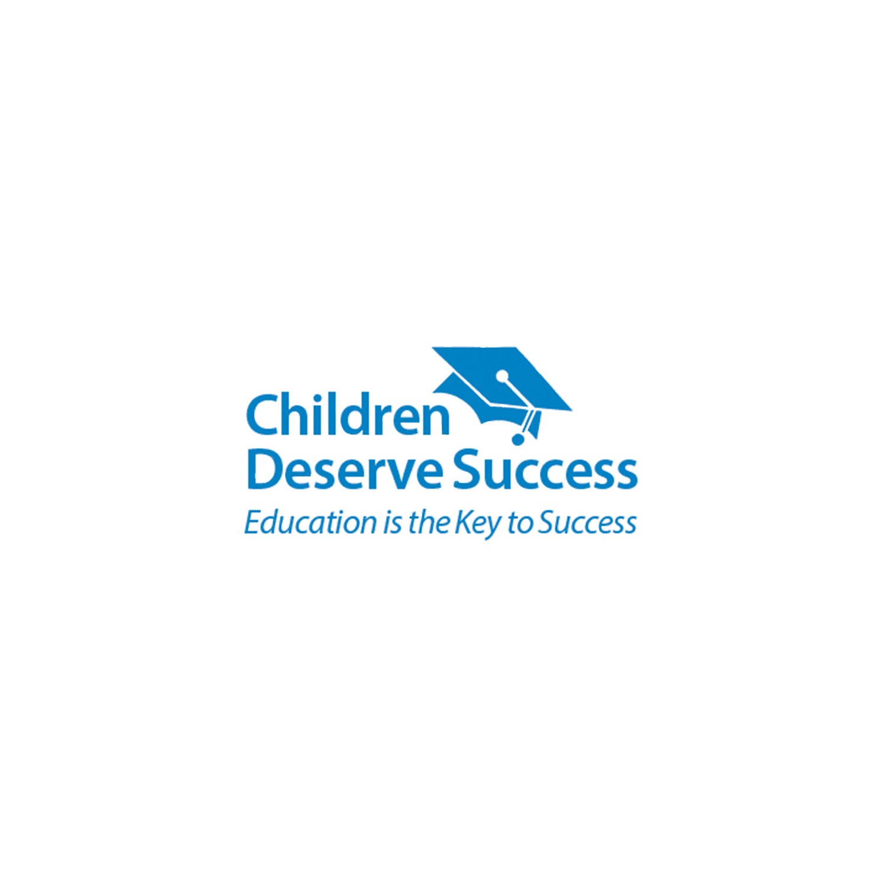
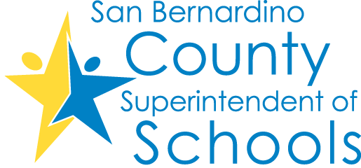
*LETTER OF RECOMMENDATION: Provide one page letter describing the student’s involvement with Homelessness, Foster Care (current or former), Probation, or other high-risk situations, and include how he/she overcame adversity and what his/her educational goals are. Attach the letter of recommendation to the application.
Donald English, Director, Children Deserve Success,
San Bernardino County Superintendent of Schools

Please email the completed application and required documents to:

Daisy Esparza
Daisy.Esparza@sbcss.net | 909.386.2757

